**PROJECT REPORT**

Project Title:

Data-Driven Insights On Olympic Sports Participation And Performance

Team ID : LTVIP2023TMID00427

Team Size : 4

Team Leader : GUNDU TRIVENI

Team member : LOPINTI SWETHA

Team member : THOTA JYOTHI

Team member : KANDI UMADEVI

Faculty Menter: P.S.KIRAN KUMAR

**INDEX**

1 Introduction

1.1 Overview

1.2 Purpose

**2** **Literature Survey**

2.1 Existing Problem

2.2 Proposed Solution

**3**  **Theoritical Analysis**

3.1 Block diagram

3.2 Hardware/Software Designing

**4**  **Result**

**5 Advantages & Disadvantages**

**6** **Applications**

**7** **Conclusion**

**1.INTRODUCTION**

The Olympic games are international sports events with more than 200 nations participating in various competitions. The Sportspersons from various countries participate in competitions and make their countries proud of their excellence in sports. Despite massive population, many most populous countries fail to grab many medals at the Olympic games. The primary objective of this paper is to analyse the Olympic dataset using python to compare overall performance of countries and to evaluate the contribution of each country in Olympics. These analyses will give deeper insight into the performance of countries in Olympics over the years and helps sportspersons to quickly analyse their own and the competitor’s performance.

the exploratory data analysis techniques are used to provide comparison between performance of various countries and the contribution of each country in Olympics. Visualization of Olympics dataset in many aspects provides the status of countries in Olympics and helps countries with poor performance to produce quality players and improve nation performance.

1.1 OVERVIEW

The modern Olympic Games or Olympics are leading international sporting events featuring summer and winter sports competitions in which thousands of athletes from around the world participate in a variety of competitions. The Olympic Games are considered the world’s foremost sports competition with more than 200 nations participating. The Olympic Games are held every four years, with the Summer and Winter Games alternating by occurring every four years but two years apart.

The evolution of the Olympic Movement during the 20th and 21st centuries has resulted in several changes to the Olympic Games. Some of these adjustments include the creation of the Winter Olympic Games for snow and ice sports, the Paralympic Games for athletes with a disability, the Youth Olympic Games for athletes aged 14 to 18, the five Continental games (Pan American, African, Asian, European, and Pacific), and the World Games for sports that are not contested in the Olympic Games. The Deaflympics and Special Olympics are also endorsed by the IOC. The IOC has had to adapt to a variety of economic, political, and technological advancements. As a result, the Olympics has shifted away from pure amateurism, as envisioned by Coubertin, to allowing participation of professional athletes. The growing importance of mass media created the issue of corporate sponsorship and commercialisation of the Games. World wars led to the cancellation of the 1916, 1940, and 1944 Games. Large boycotts during the Cold War limited participation in the 1980 and 1984 Games. The latter, however, attracted 140 National Olympic Committees, which was a record at the time.

**1.2 PURPOSE**

The Olympic Games are an international sports festival, held every four years. The ultimate goals are to cultivate human beings, through sport, and contribute to world peace. Summer Games and Winter Games are held separately.  
In 2012, the commemorative XXX Olympic Games were held in London, with athletes from 204 countries and regions participating in 26 sports, with a total of 302 separate events.

The history of the Olympics began some 2,300 years ago. Their origin lays in the Olympian Games, which were held in the Olympia area of ancient Greece. Although there are some theories on its initial purposes, the Games have been said to have started as a festival of art and sport, to worship gods. The ancient Olympic Games, however, ended in 393 because of the outbreaks of wars in the region in which they were held. After absence of the ancient Olympic Games, the event was resumed in the late nineteenth century, thanks to the efforts of Baron Pierre de Coubertin, a French educator. In 1894, his proposal to revive the Olympic Games was unanimously approved at the International Congress in Paris, and the first Olympic Games were held in Athens, Greece, two years later. He also devised the five-ring emblem that is familiar to most people as the Games’ symbol, which represents the unity of the five continents. Olympism, the spirit of the Olympic Games advocated by Coubertin, is “The elevation of the mind and soul, overcoming differences between nationalities and cultures, embracing friendship, a sense of solidarity, and fair play; ultimately leading to the contribution towards world peace and the betterment of the world.

**2. Literature Survey**

**2.1 Existing problem**

**The Olympics are built on excess, tangled in geopolitics, rife with corruption and cheating**. Each Olympic cycle raises uncomfortable questions about sustainability, environmental damage and human rights. The Games are presented as apolitical, but that is both impossible and untrue. The Olympics create unequal cities. The very nature of the games leads them inexorably to the problems that have plagued the Olympics for the better part of the last half-century:”**skyrocketing, budgets, corruption”.** The modern Olympics, founded in the 1890s as a way to showcase “a life based on the joy found in effort, the educational value of a good example and respect for universal fundamental ethical principles,” are now synonymous with scandal of many varieties, including **doping, bribery and physical abuse of athletes**.

The rate of participation of women in the Olympic Games has been increasing since their first participation in 1900. Some sports are uniquely for women, others are contested by both sexes, while some older sports remain for men only.

**2.2 Proposed Solution**

The proposed list of four sports only, of which three sports are already confirmed by the IOC on the Tokyo 2020 Olympic programme, leads to a belief that Paris 2024 and the IOC favoured sports already in the Olympic programme, leaving practically no opportunity for other sports.""Our sport has grown exponentially over the last years, and we still haven't had the chance to prove our value as an Olympic sport since we will be making our debut as an Olympic discipline in Tokyo 2020"Over the last months, we have worked relentlessly, together with the French Federation, to achieve our goal of being included in Paris 2024."We believed that we had met all the requirements and that we had the perfect conditions to be added to the sports programme however, we have learned today that our dream will not be coming true. "Breakdancing” was one of the sports at the Youth Olympic Games in Buenos Aires in 2018, and now could see its profile dramatically raised.

Under new IOC rules first introduced for the Tokyo Games, Olympic host cities can hand-pick sports and propose them for inclusion in those Games if they are popular in that country and add to the Games' appeal. The IOC needs to approve the French proposals before they can be formally added to the Paris Games sports Programme. Millions of people across the world tune in every four years to be entertained and inspired, marvel at gymnasts defying physics, and feel bad about their own bodies.

**3. THEORITICAL ANALYSIS**

**3.1 Block diagram**

Creating a detailed block diagram for Data driven insights on Olympic sports participation and performance involves breaking down the process into key steps and components. Below is a high-level block diagram outlining the main stages and elements involved in Olympic sports participation and performance The block diagram illustrates the end-to-end process of data driven on Olympic sports participation ,starting from data collection and preprocessing to deploying the final models of Olympic sports.

DATA DRIVEN INSIGHTS ON OLYMPIC SPORTS OF PARTICIPATION AND PERFORMANCE

**DATA COLLECTION**

**PROBLEM UNDRESTANDING**

**DATA PREPARATION**

**DATA VISULIZATION**

**DASHBOARD**

**STORY**

**REPORT**

**WEB INTEGRATION**

**3.2 Hardware/software designing**

Designing hardware and software for Olympic sports involves creating specialized equipment and technology to enhance athlete performance and provide accurate data for analysis. It typically includes:

Hardware:

* Sports Equipment: Developing high-quality gear and tools specific to each sport, such as track and field implements, swimming equipment, archery bows, etc.
* Timing Systems: Creating precise timing devices to record athletes' performances in events like sprinting, swimming, and cycling.
* Sensors and Wearables: Incorporating sensors and wearables to track athletes' movements, heart rate, and other biometric data during training and competition.
* Video Analysis Systems: Building video analysis tools that capture and analyze athletes' performances for coaching and training purposes.

**Software:**

* Performance Analysis Software: Developing software to process and interpret data collected from sensors and variables, helping coaches and athletes optimize training strategies.
* Simulation and Modeling: Creating virtual environments to simulate real-world conditions for training and strategy development.
* Competition Management Systems: Designing software to manage and schedule Olympic events, including athlete registration and scoring.
* Training Apps: Developing mobile apps to support athletes with personalized training programs and progress tracking
* **4.RESULT**
* **DASHBOARD:**
* 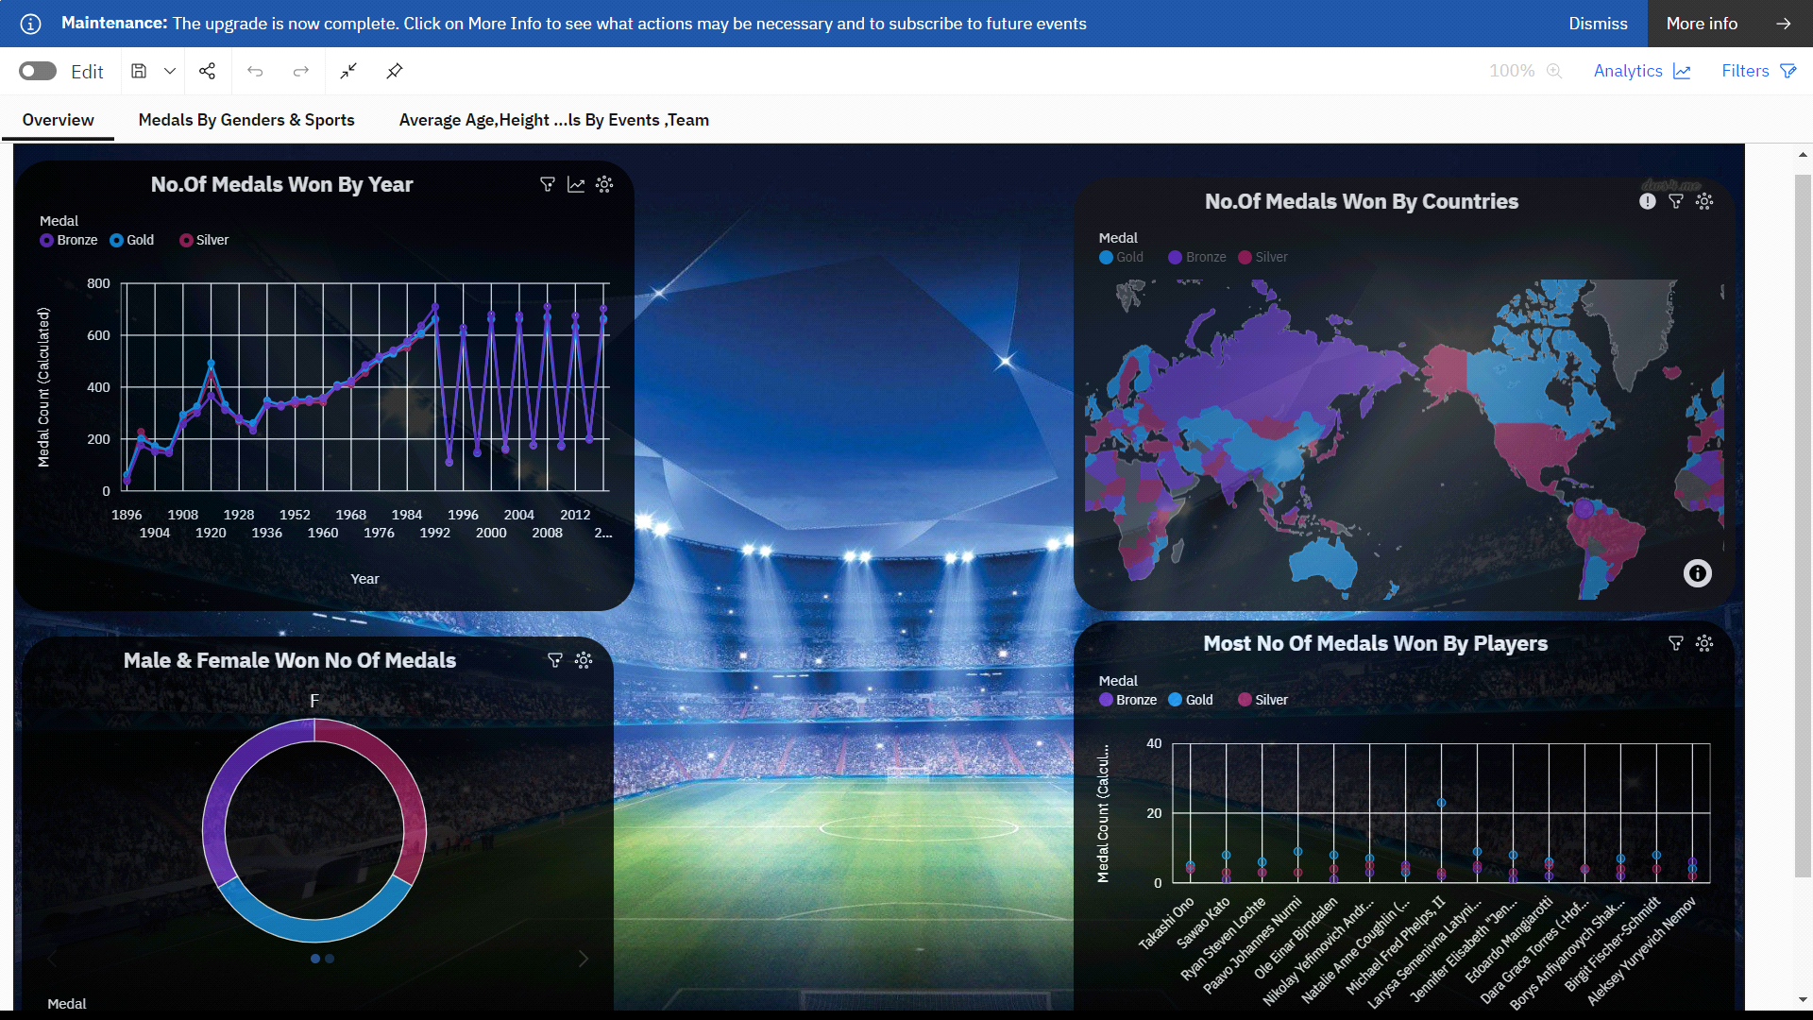

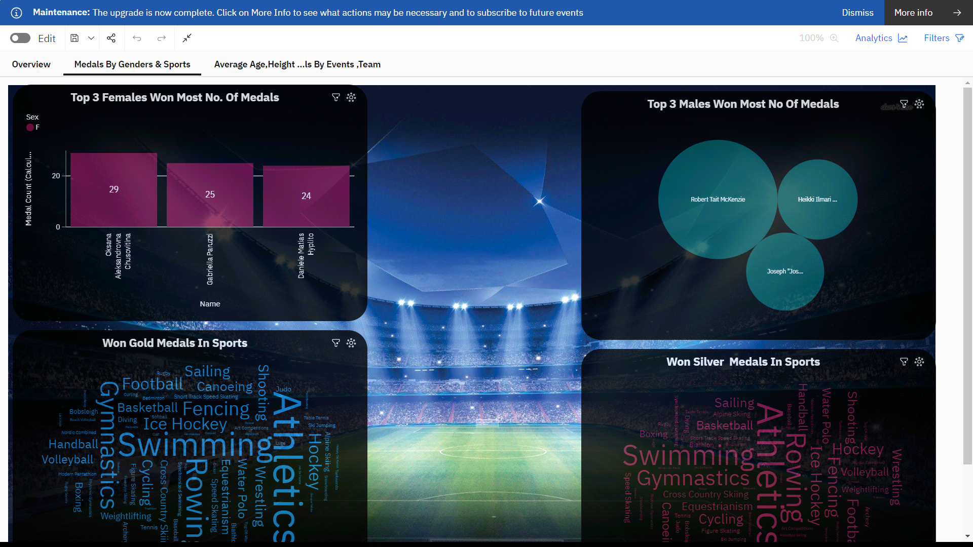

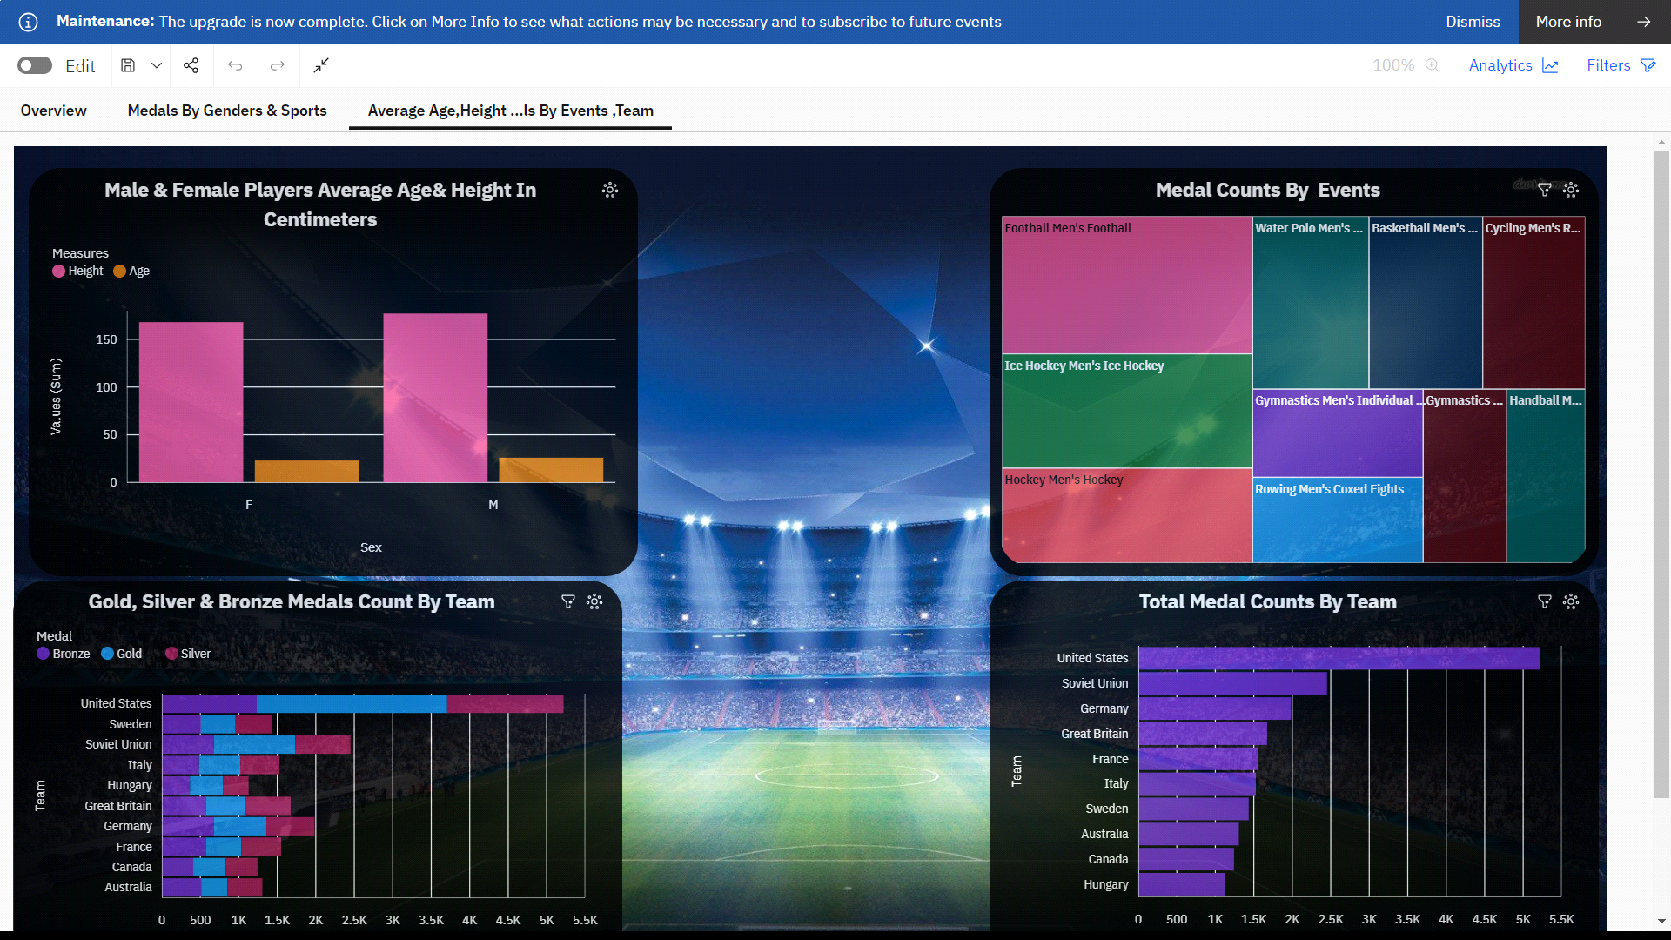

**STORY:**



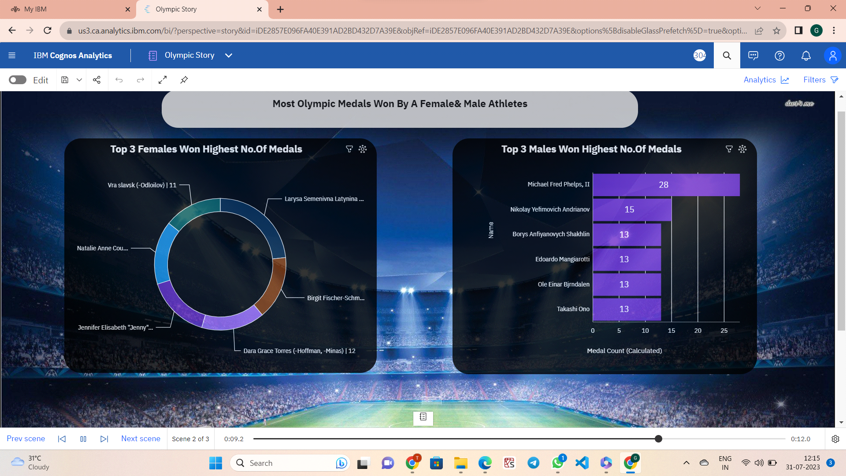

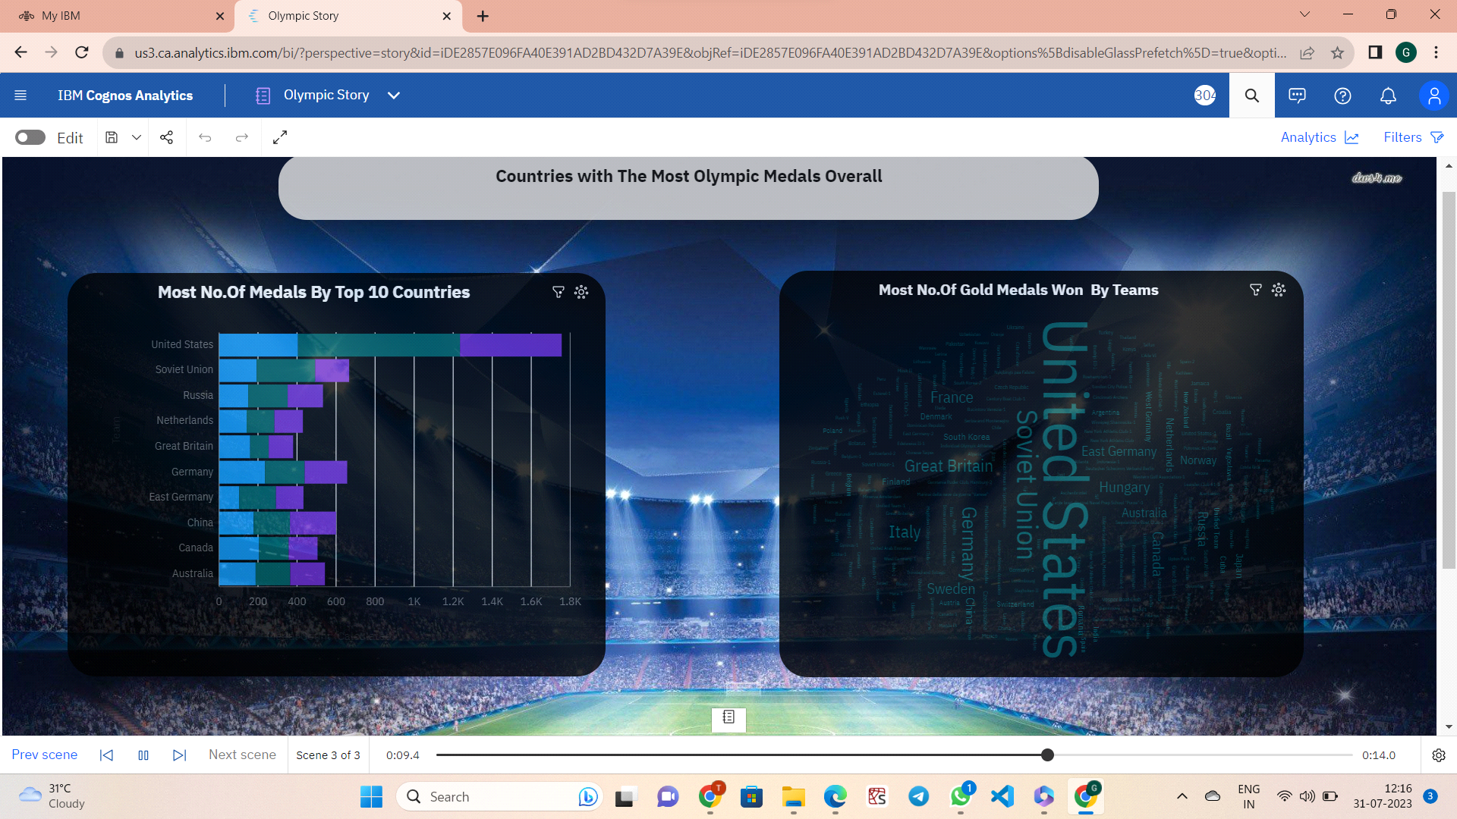



**REPORT:**

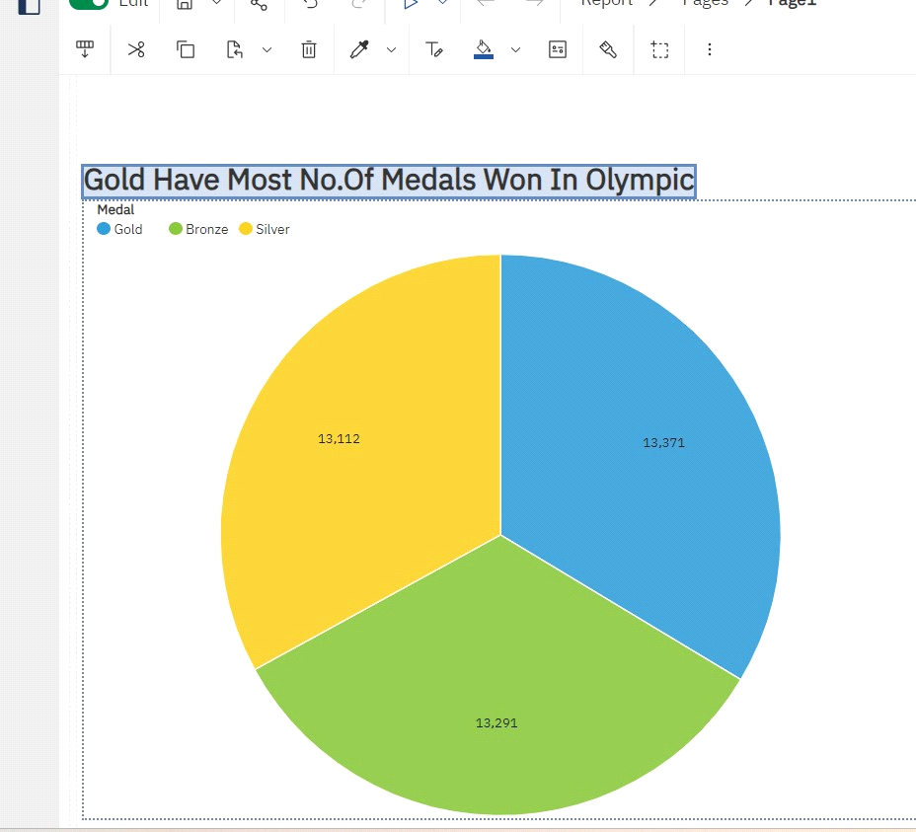

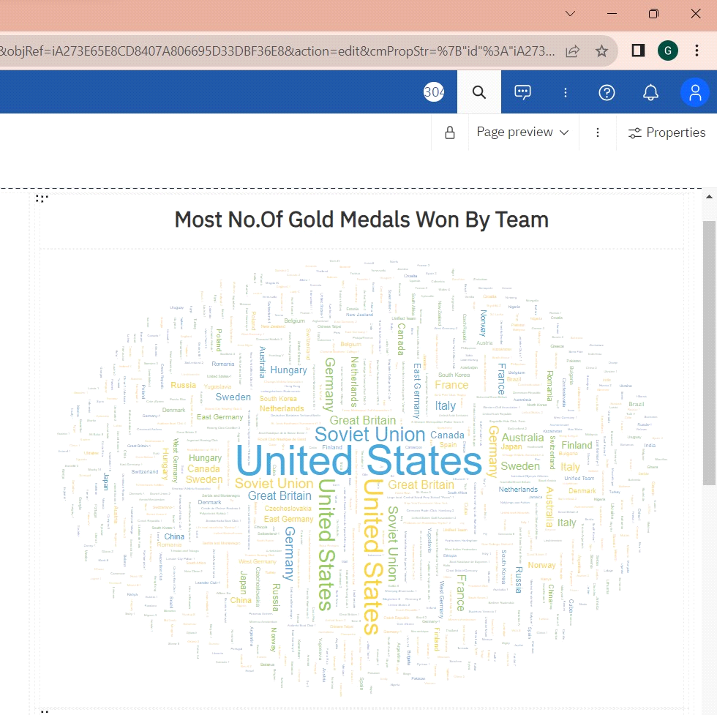

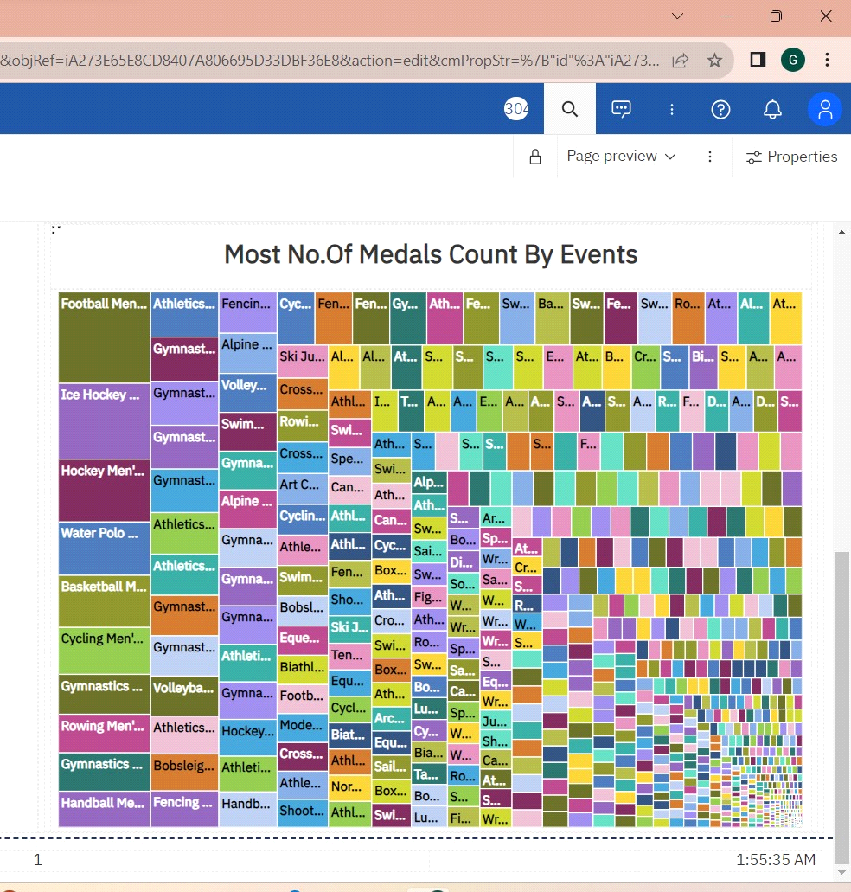

**WEB INTEGRATION:**





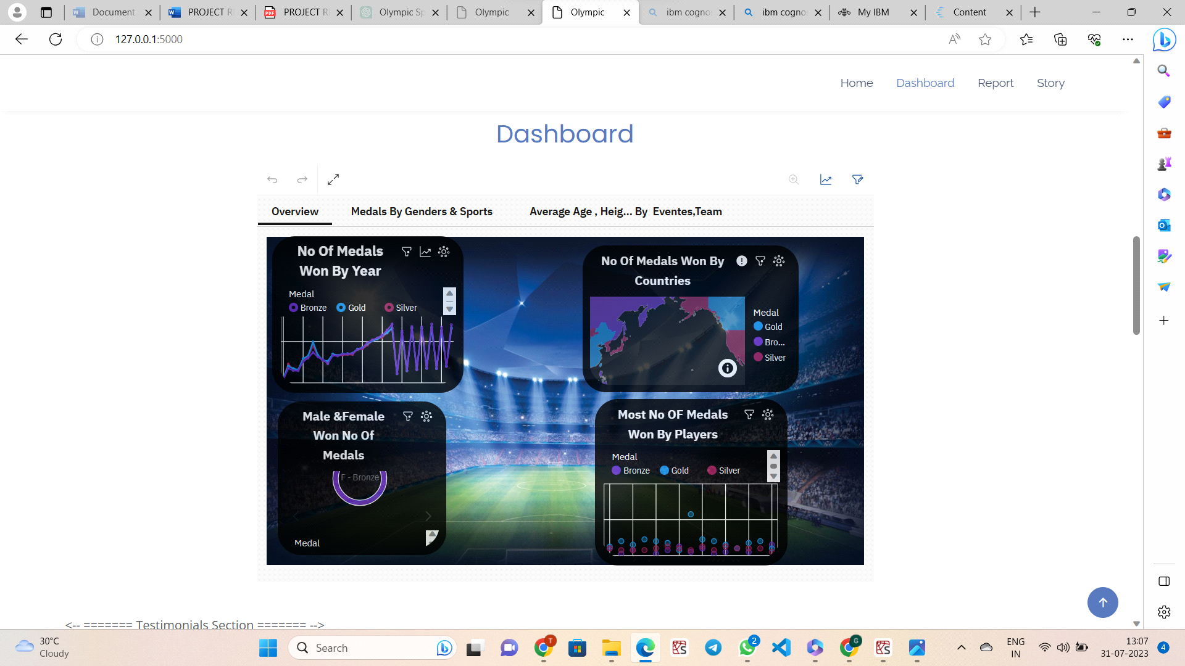





**5.ADVANTAGES**:

* Prestige
* Economic “spin-offs” such as trade and tourism
* It unites the country and gives a sense of pride
* Cities build or improve facilities to host events
* It gives a boost of sports facilities and other facilities

**DISADVANTAGES:**

* Financial drain on host cities
* Creation of expensive infrastructure and buildings that fall into disuse
* Displacement and burden of residents of the host country and city
* Large debts and maintenance liabilities for host countries
* Negative publicity
* **6.APPLICATIONS:**
* Athlete Training: Coaches and athletes use performance data to identify strengths and weaknesses, tailor training programs, and improve performance in their respective sports.
* Sports Science and Technology: Advancements in sports science and technology are applied to optimize training, nutrition, recovery, and equipment, leading to enhanced performance.
* Injury Prevention and Rehabilitation: Sports performance strategies also focus on preventing injuries and providing effective rehabilitation to athletes to ensure their optimal participation.
* Performance Analysis: Performance data is analyzed to strategize and improve game plans, tactics, and decision-making during competitions.
* Sports Psychology: Olympic athletes often work with sports psychologists to enhance mental toughness, focus, and motivation, which are crucial for success on the world stage.
* performance, helping to maintain energy levels and promote recovery.

**7.CONCLUSION:**

As of my last update in September 2021, Olympic sports performance has been consistently improving due to advancements in training techniques, technology, and nutrition. Athletes from various countries have been setting new records and achieving remarkable feats. However, for the most up-to-date conclusion on Olympic sports performance, I recommend checking recent news and statistics, as the landscape of sports is constantly evolving.

**8.FUTURE SCOPE**:

The future scope of data-driven insights on Olympic sports participation and performance is vast and holds immense potential for positive impact. Here are some key areas where data-driven insights can shape the future of the Olympics:

* Personalized Training and Recovery: As technology continues to advance, athletes can benefit from more personalized training and recovery programs based on their individual data. This can optimize their performance, reduce the risk of injuries, and enhance overall well-being.